Part 1

Our journey started locally, we left home and left for West Drayton Station. Let me explain a little about our transport system in England. We have two different types of rail networks, one is a network, which covers the whole of England, run by various transport companies now. We call this The Main Line. The other one is found in London (but there are a few cities which do have the same type of transport), and is called The London Underground. As the name suggests, the trains sometimes go very deep underneath London, in tunnels, but as you travel outwards from London, they tend to be over ground. Here is what we call a tube map. It's all the stations that are part of the London Underground. Our nearest underground station is Uxbridge, on the far left-hand side of the map, it's about 2 miles from where we live.
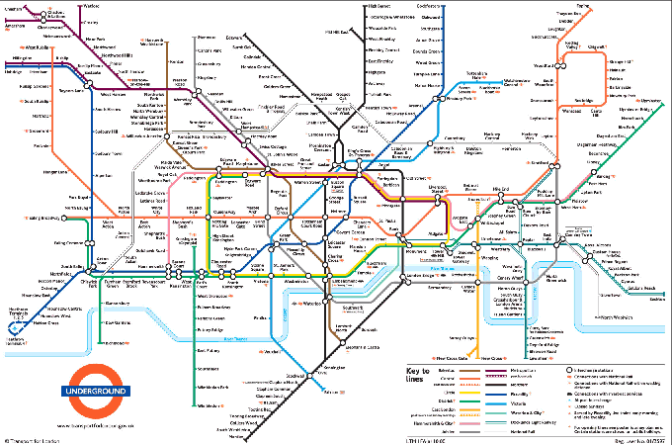 рисунок 2

Part 2

On this particular day though, we chose to go into London from West Drayton (the Main Line). Our destination station was Paddington, which is in the heart of London.
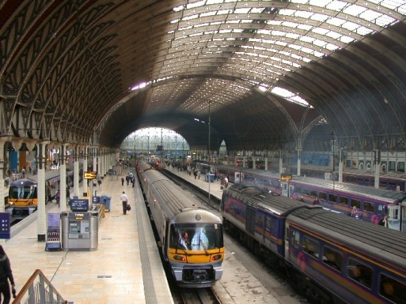
This is part of Paddington Main Line Station, it's a lot bigger than what is shown.
Let me try to explain a little about our fares. We have lots of options, you can pay for single tickets, return tickets, season tickets (that means you purchase one ticket which will last you for a whole month or a whole year), and you can also buy special tickets. We knew we would be using the trains and buses a lot on this particular day, so our best option was to buy a One Day Travel Card. This gives you unlimited travel on the
Underground, buses and Main Line stations that are in London, and it costs £5.

рисунок 3

This is a typical underground station and an underground or overground train:
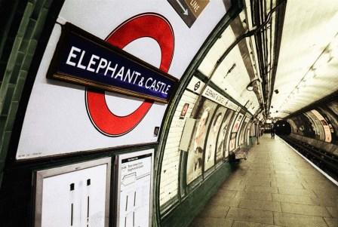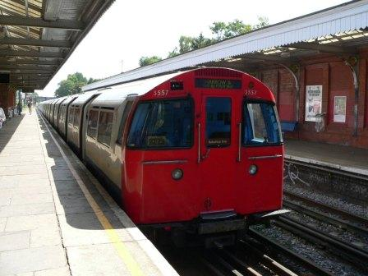
Рисунок 4 рисунок 5
Part 3

Our train arrived and within 20 minutes we were in London. Some stations in London are served by both the Main Line and the Underground, this is the case for Paddington. We chose to go in on the Main Line because it is quicker than using the Underground. We arrived at Paddington, and left the station to get a bus outside which would take us to Oxford Street, a very well known shopping street in London. After a few minutes, the number 5 bus came along and we got on it. We have lots of different types of buses now, but in years gone by, the bus below was the most popular and is so reliable they are still used today.

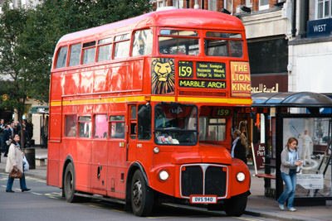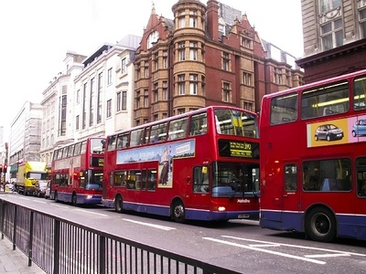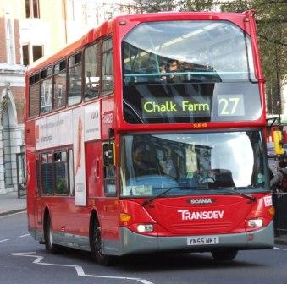

рисунок 6 рисунок 7 рисунок 8
And here are some more modern buses.

As you can see, some are what we call double-deckers and some are single-deckers. The older type buses have a driver and a conductor, that's someone who walks around the bus collecting the fares and issuing tickets. The newer buses just have a driver, and he collects your fare and issues your tickets as you board. We didn't have to buy a ticket, as we had bought our One Day Travel Card, so we just showed this to the driver or conductor each time we boarded a bus.

Part 4

We made our way the short distance from Paddington Station to Oxford Street, the roads were quite busy and there was a lot of traffic. Another form of transport you will see on the streets of London is a London Taxi. These are commonly known as Black Cabs and there are literally hundreds of them in London. They are quite expensive, the fare is worked out using a meter in the Taxi, so the further distance you go, the more expensive it will be. If you only have to go a short distance and are in a hurry, it's a quick way of getting around London. This is a London Taxi:
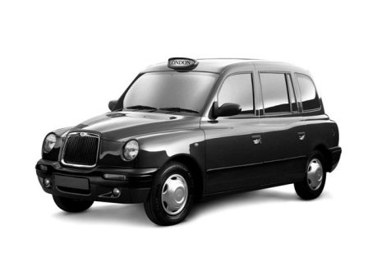
рисунок 9

We left the bus in Oxford Street, and browsed round the shops for a while, and then we decided to have some lunch. We stopped at a pizza restaurant, and we had an eat as-much-as-you-like buffet, which is exactly what it says. For ₤3.95 you can eat as much pizza, pasta and salad as you wish. We had a very pleasant lunch indeed. We bought some souvenirs for you, which hopefully you will be able to see for yourself very soon.

Part 5

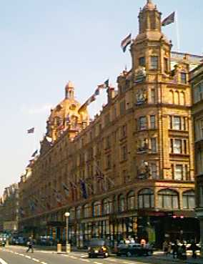
Our main purpose of travelling into London was to go to a shop called Harrods. This is the most famous shop in England. Harrods is in a part of London called Knightsbridge. It's owner is Mohammed A1 Fayed, the father of Dodi A1 Fayed, who was the person involved with our Princess Diana. They were both killed in Paris a few years ago, I'm sure you must have heard about it. The shop is extremely plush, and terribly expensive, but it sells absolutely everything, at a price! You can buy anything from food to sports cars.

This is Harrods.

Рисунок 10

We spent an hour or so here, just browsing as everything is so expensive. Nearly every tourist who visits England will come here. This is where I bought your tea!
After leaving Harrods, we got on another bus and headed back towards Oxford Street, by this time it had started pouring with rain, so we decided to take shelter in a pub.

Part 6

When it stopped raining, we decided to make our way home, and got on the bus back to Paddington. Unfortunately there was a problem with the train drivers going on strike (this means they had a grievance with the company they worked for and refused to work).
There was no indication of the time of the next possible train, so we decided to go back using the Underground this time. Unfortunately, our car was parked at West Drayton Station, and the Underground train would take us back into Uxbridge. It's only a very short bus ride away, but we were really tired by now.
We arrived back in Uxbridge at about 10 pm and decided to have a meal in one of our local pubs, called the Swan and Bottle. After a lovely meal, I telephoned to ask my eldest son David, if he would come and pick us up in his car, which he did. So we arrived home, some 8 hours later, tired but having had a really nice day.
I hope you enjoyed looking at the pictures and reading all about our day in London.

